- The Bonny Kate Elementary Library Media Center Website is located at:
http://knoxschools.org/domain/3354




Worldbook Online Encylopedias for all grades

Username: knoxcounty
Password: elvis
Database  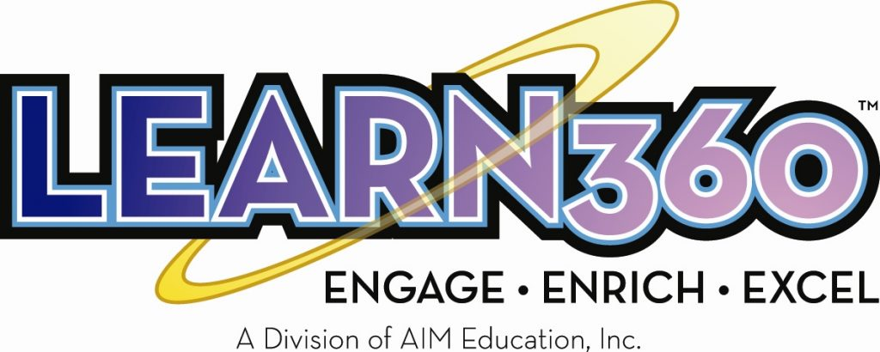  Username: knoxcs  Password: govols | Database    (Encyclopedia & Magazine Articles)    Password: elvis | Social Studies & Science Databases    Username: knoxcounty  Password: govols

- The Bonny Kate Elementary Library Media Center Website is located at:
http://knoxschools.org/domain/3354

Worldbook Online Encylopedias for all grades

Username: knoxcounty
Password: elvis
Database  Username: knoxcs  Password: govols | Database  (Encyclopedia & Magazine Articles)  Password: elvis | Social Studies & Science Databases  Username: knoxcounty  Password: govols

- The Bonny Kate Elementary Library Media Center Website is located at:
http://knoxschools.org/domain/3354

Worldbook Online Encylopedias for all grades

Username: knoxcounty
Password: elvis
Database  Username: knoxcs  Password: govols | Database  (Encyclopedia & Magazine Articles)  Password: elvis | Social Studies & Science Databases  Username: knoxcounty  Password: govols

