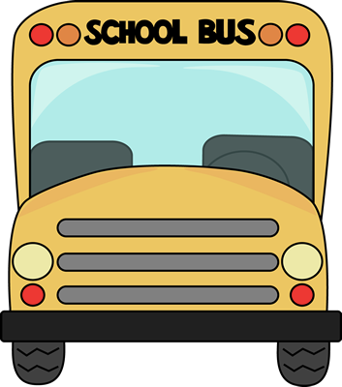Kindergarten

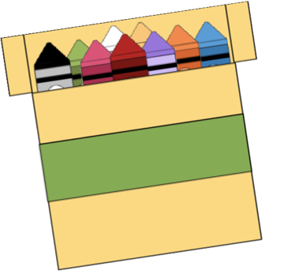

School Supply List

* 3- Boxes of Tissues
* 1- Pack of Crayons
* 1- Pack of Erasers
* 1- Pack of Pencils
* 1- Fiskar Scissors
* 1- Pack of Glue Sticks
* 1- Box of Quart size baggies
* 1- Box of Gallon size baggies