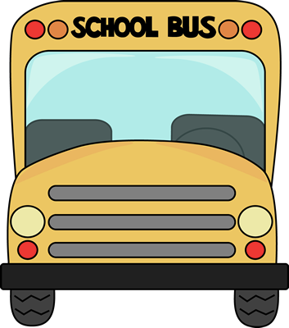3rd Grade

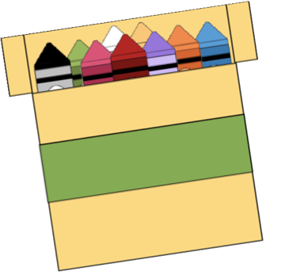

School Supply List

* 1- Pencil Pouch
* 1- Pack of Dry Erase Markers (Black)
* 3- Boxes of Tissues
* 1- Pack of large pink Erasers
* 2- Pack of Pencils
* 1- Headphones/earbuds
* 1- Colored Pencils
* 1- Pack of Crayons
* 1- Pack of colored pencils
* 1- Box of Quart size baggies
* 1- Box of Gallon size baggies