4th Grade

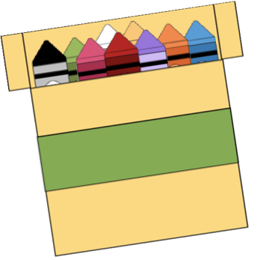

School Supply List

* 1- Pencil Pouch
* 1- Pack of Dry Erase Markers (Black)
* 3- Boxes of Tissues
* 2- Packs of pencil top erasers
* 2- Pack of Pencils
* 2- Packs of Glue Sticks
* 4- 3 Prong Folders
* 4- Spiral Notebooks
* 1- Headphones/earbuds
* 1- Pack of Copy Paper