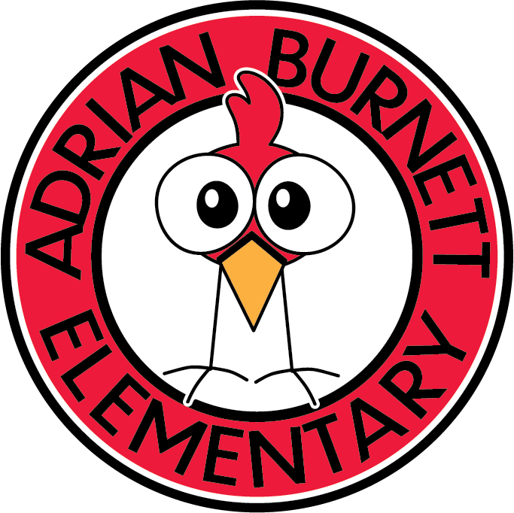

***ADRIAN BURNETT ELEMENTARY TITLE I***

***PARENT INVOLVEMENT COMPACT***

Adrian Burnett Elementary School staff, parents and students are full partners in student learning and achievement. In order to improve student learning and meet the high levels of academic achievement, we pledge to:

***School Responsibilities***

* **Provide high quality instruction in a supportive, engaging learning environment.**
* **Include parents in development and evaluation of school policies.**
* **Provide opportunities for parents to participate in their child’s education.**
* **Keep parents informed of students’ progress.**
* **Respect cultural diversity of students and families.**
* **Communicate in a timely manner.**

**Principal Signature:** Mrs. Stephanie Prince

***Parent Responsibilities***

We ask parents to:

* + **Encourage a positive attitude about school.**
  + **Provide a quiet place for any work that comes home.**
  + **Monitor TV and video game time.**
  + **Ensure regular and punctual school attendance.**
  + **Maintain on-going communication with school.**
  + **Attend parent-teacher conferences, whether in-person or virtually.**
  + **Read with children.**
  + **Participate in school activities, whether in-person or virtually.**
  + **Read and adhere to the parent/student handbook.**

**Parent Signature_________________________________ 2020-2021**