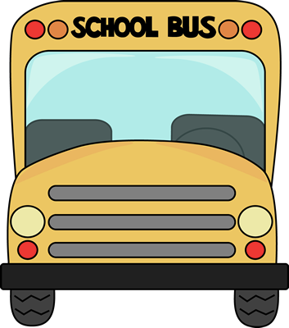2nd Grade

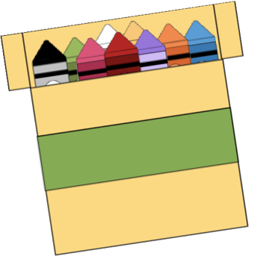

School Supply List

* 3- Boxes of Tissues
* 1- Pack of large pink Erasers
* 2- Pack of Pencils
* 1- Fiskar Scissors
* 2- Packs of Glue Sticks
* 1- Box of Quart size baggies
* 1- Box of Gallon size baggies
* 1- 3 prong folder
* 1- Composition notebook
* 1- pack of copy paper