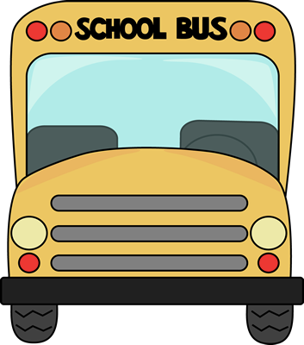Pre-K

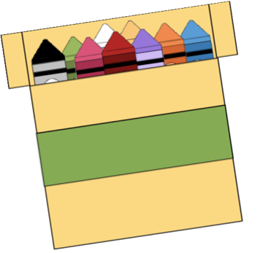

School Supply List

* 1 – Pencil Box
* 1- Water Bottle
* 1- Bottle of ketchup
* 1- Pack of Baby Wipes